**COMPUTER NETWORKS - CSA07**

**Parthibhan .R**

**192224275**

**EXPRIMENT 8:-**

Subnetting – Class C Addressing

Github Link:- <https://github.com/parthibhan007/CSA0748-computer-network/tree/main/expriment%208>

Simulation:-

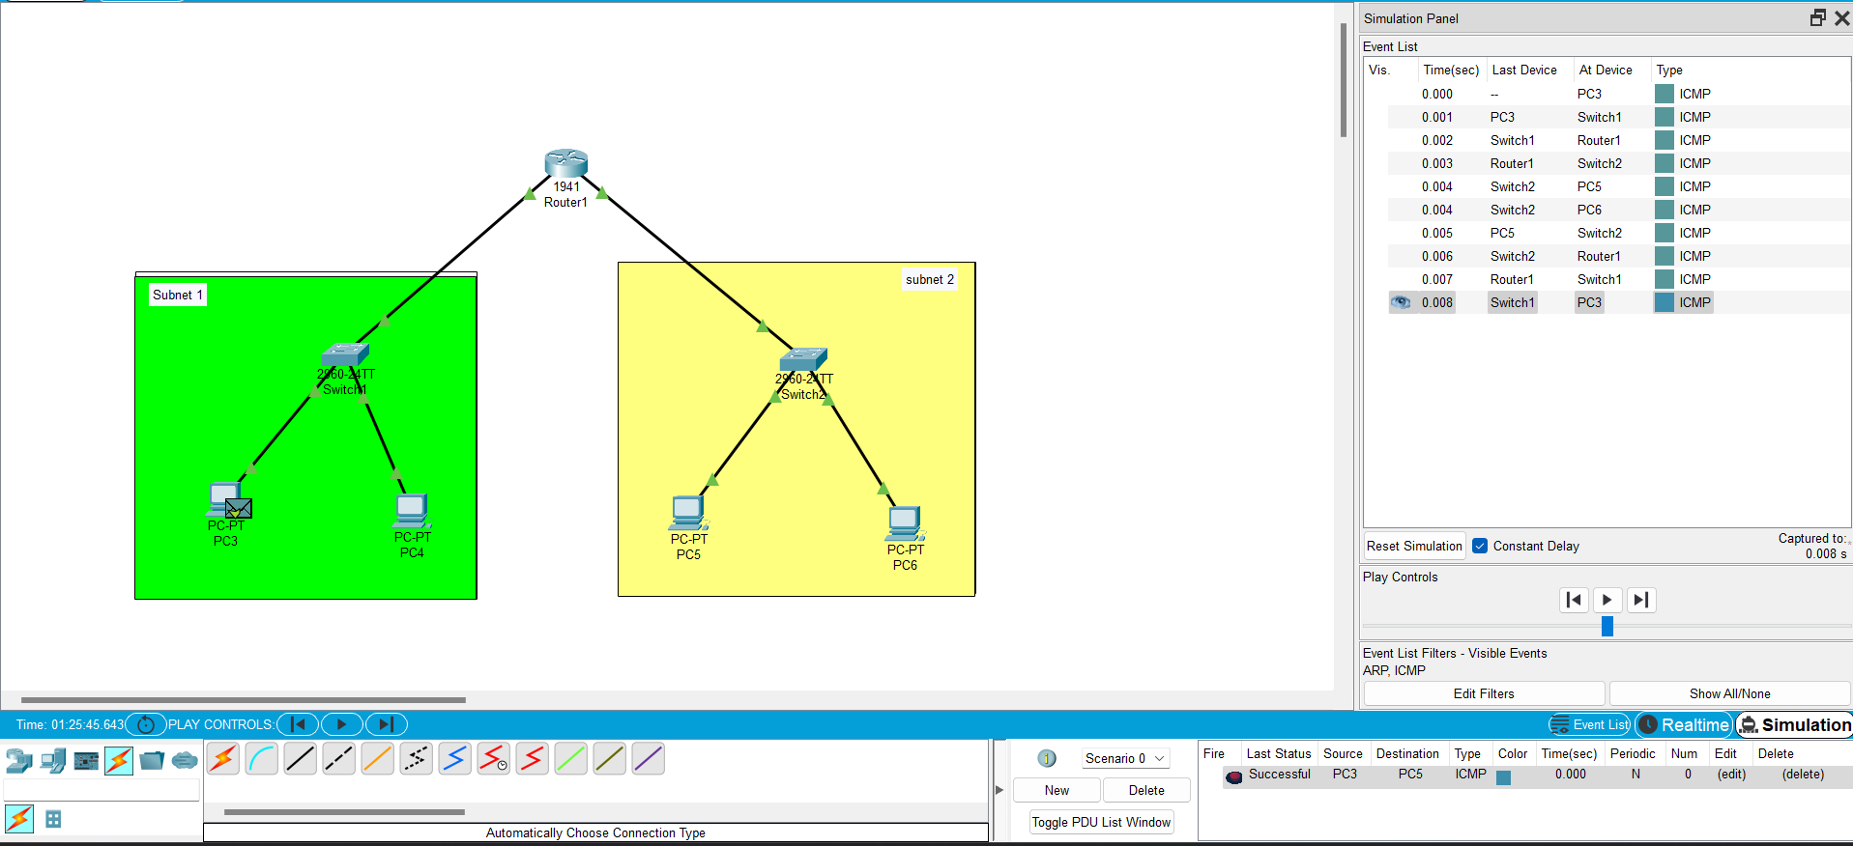

Real Time:-

